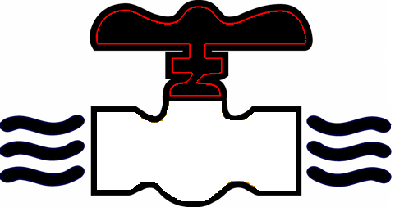
MODERN PLUMBING INDUSTRIES, INC.
255 Old Sanford Oviedo Road ~ Winter Springs, FL 32708
Telephone 407-327-6000 ~ Fax 407-327-2303
www.modernpi.com

BENEFIT/PAYROLL DEDUCTION CANCELLATION

Effective Date:
Selection {check all that apply}:
 | Medical
 | Dental
 | Pre-Paid Legal
 | Identify Theft
 | Guardian/Additional life
Employee Name {print} |  |  |  |  |  |  |  | Date
Signature

OFFICE ONLY:
Payroll Processed by: |  |  |  |  |  |  | Date:
Provider Notified by: |  |  |  |  |  |  | Date:

